# Technical Documentation

# Introduction

## Types of data structures

The data structure allows you to arrange your data so that you may store data, relate them, and carry out actions on them appropriately, which is implicitly supported by Python.

Data Structures in python

User-Defined Data Structures

Built-in Data Structures

Graph

Stack

Tree

Set

Dictionary

List

### **Linked List**

Tuple

Array

HashMap

**- Built-in Data Structures:**

**1- List:** Lists are employed to sequentially store data of various data kinds. Every item in the list, also known as the Index, has an address allocated to it. The index value begins at 0 and continues until the final component, which is the positive index. You may also retrieve items from last to first using negative indexing, which starts at -1.

**You have a lot of functions that can be used when working with lists.**

The remove () method is used to delete an element based on its value.

The length of the list is returned to us by the len () method.

The index () method locates the value passed's the index value at the location where it was first encountered.

The count of the value provided by the count () method is determined.

Sorting the list's values is what both the sorted () and sort () methods accomplish.

(edureka, 2022)

**2- Dictionary:** is employed to store information as key-value pairs, also dictionary is a group of items that are unique (duplicates are not allowed), changeable, and ordered*.

**Unique:** dictionary elements cannot share the same key twice:

**Changeable:** this means that after they have been built, we may edit, add, or delete elements.

**Ordered:** It indicates that the elements are in a set sequence that won't change.

Curly brackets are used in dictionary building, and they contain keys and values

Dictionary elements' values can be of any data type, Printing the data type of a dictionary by type () function

(edureka, 2022)

**3-Tuples:** are similar to lists with the difference that once data has been inserted into a tuple, it cannot be edited under any situation. The tuple data may only be edited when the data inside it is changeable, which is the single exception.

Round brackets are used for writing tuples.

The items in a tuple are ordered, unchanging, and allow for duplicate values.

**Ordered:** It means that the elements are in a set sequence that won't change.

**Unchangeable:** meaning that after the tuple has been generated, we cannot add, delete, or edit any of the components.

**Allow duplicates:** they may own things of equal value

(edureka, 2022), (w3schools, 2023)

**4-set:** To store several objects in a single variable

Curly brackets are used for writing sets.

Sets are Unchangeable, unordered set elements do not permit duplicate values.

**Unchangeable:** after the set has been established, we are unable to modify the items.

**Unordered:** Every time you use a set item, it may appear in a different order. Set items cannot be accessed using an index or key.

**Do not permit duplicate values:** Two items with the same value cannot be in a set.

(edureka, 2022)

**User-Defined Data Structures:**

**1-Graph:** a non-linear data structure having vertex and edge elements, many difficulties in everyday life may be resolved with graphs. Networks are shown using graphs.

**Vertex:** these are the basic elements of the graph.

**Edge:** drawn or used to join two graph nodes

(edureka, 2022), (geeksforgeeks, 2023)

**2-Tree:** A tree is a type of data structure where information is arranged hierarchically and connected through references. Every tree has a root node from which we may access each of the tree's elements.

**Root Node:** The root node is a tree's highest point.

**Parent Node:** Any node that refers to another node is said to be that node's parent.

**Child Node**: When employing references, a parent node's child nodes are the nodes that the parent node is pointing at.

(edureka, 2022), (Raj, 2021)

3-**Linked lists:** are linear Data Structures that are connected to one another via pointers rather than being stored sequentially. The most common apps that employ these structures are those that play music, examine images, and so on.

(edureka, 2022)

**4-Stack:** is a linear data structure that fits to the Last In First Out principle (LIFO). This implies that the last piece to be added to the stack gets eliminated first.

(edureka, 2022), (programiz, 2023)

**5-HashMaps:** are equivalent to Python's dictionaries. In addition to many other things, they may be used to construct apps like phonebooks and populate data with lists.

(edureka, 2022)

**6-Array:** is a group of objects kept in close proximity to one another in memory. The aim is to group objects of the same category for storage. This makes it simpler to determine each element's location by only adding an offset to a base value.

(geeksforgeeks, 2023)

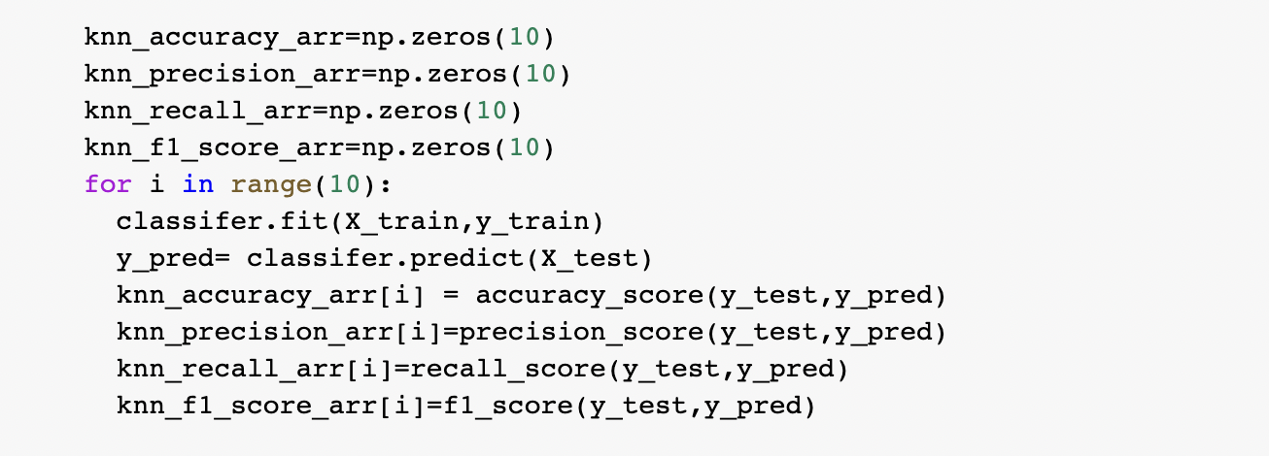

Here is a small example in my code when I used a Array, as we can see I created four Arrays from 10 columns and I fill it with zeros

I created the array because I want to save all the values that are coming from the loop

## Common libraries

**Pandas library:**

A library for data analysis and manipulation is called the panda's package. Pandas may be the most extensively used Python package given Python's prominence in the data science environment.

Data cleaning and preprocessing take a lot of time when developing a data-based product or a machine-learning model. The preparation of the data might take up to 80–90% of the time. Additionally, pandas provide several features that make the process of getting the data ready easier.

**I used the panda library to:**

**1-To Load Data:**

so I can load the CSV file and open it to read, just by writing this syntax (pd.read_filetype()).

**2-To Make DataFrames**

**3-To Clean Data:**

By using some syntaxes such as:

pd. isnull().sum: to see how many null values I have in the data set.

df. dropna: to delete any row that contains a null value.

**4-To Fill Data:**

By using this syntax

Df. fillna(“string or int or ….”): to replace the null values with another value.

**5-To Visualize Data**

**6-To View The Data:**

By using some syntaxes such as:

df. head(): to print the data.

df. shape(): to see how many columns and rows this data is.

**7- statistics:**

By using some syntaxes such as:

df. mean(): to return the mean of all the columns.

df. Max: to return the highest value in each column.

df. Min: to return the lowest value in each column.

df. median: to return the median of each column.

**NumPy Library:**

is a library developed in 2005 by Travis Oliphant that is used to interact with arrays. Functions for working with matrices, linear algebra, and the Fourier transform are available in the Python NumPy package. An open-source project called Python NumPy is available for usage at no cost. Numerical Python is referred to as NumPy. (Team, 2022)

I used the NumPy library

To make a random choice.

By this function

np. random. choice():





As we can see here a little example of how I did use the NumPy library in my code to use a random generator

**Scikit-learn library:**

a reliable Python library. It includes a wide range of machine learning methods, including complicated neural networks and linear regression. Additionally, it offers features for feature engineering and data preparation.

This library can be used for different types of learning problems

**Classification:** a supervised learning problem with a discrete target variable. Spam email detection and picture categorization are examples of common use cases.

**Regression:** a supervised learning problem with a continuous target variable. Regression issues include things like predicting demand and stock prices.

**Clustering:** a challenge for classifying unlabelled data using unsupervised learning. Plotting and visualization libraries

(Yıldırım, 2022)

Here are some examples of how I used this library in my code:

1. I used it to split the data set into a train and test



1. I used it to import the KNN learning model



1. I used it to import the DT learning model



1. I used it to import the GB learning model

**Matplotlib:** Data science relies heavily on data visualization. It supports data discovery, interpretation, and analysis. Additionally, data visualization is a very effective tool for conveying stories and delivering outcomes, which is very challenging to achieve with simple statistics! (Yıldırım, 2022)

Python's most widely used data visualization package is Matplotlib. It may be used to make a variety of graphs, including line plots, scatter plots, and histograms. Additionally, Matplotlib supports three-dimensional plotting. (Yıldırım, 2022)

Here are some examples of how I used this library in my code:

I have used it in visualization

First I imported the library



As we can see I used it to create the bar plot

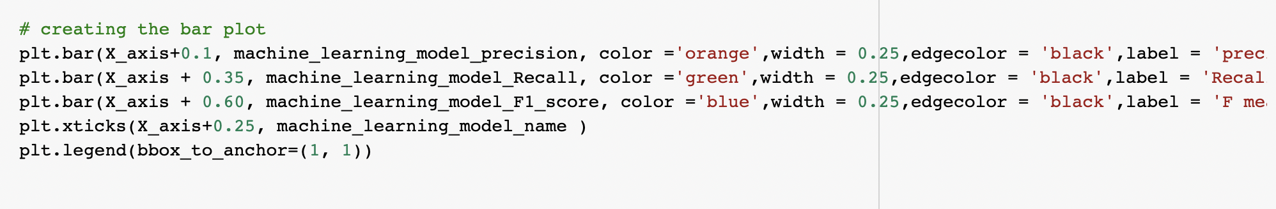

I used it here to create the boxplot for the KNN model

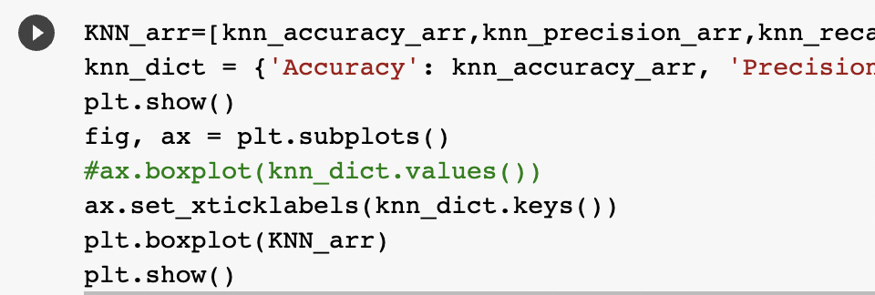

I used it here to create the boxplot for the DT model

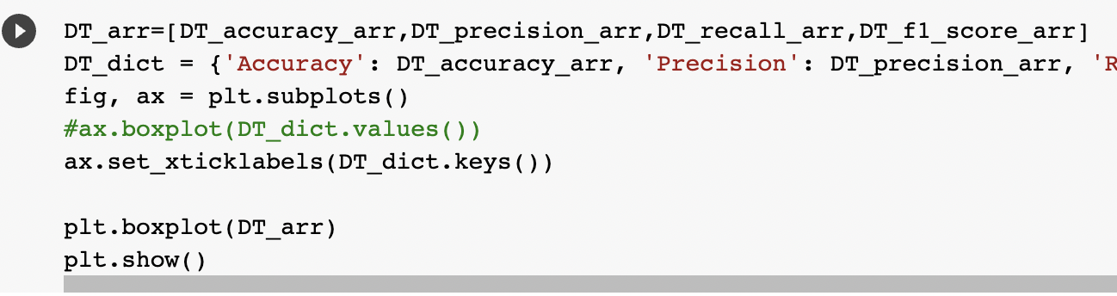

I used it to create the boxplot for the GB model

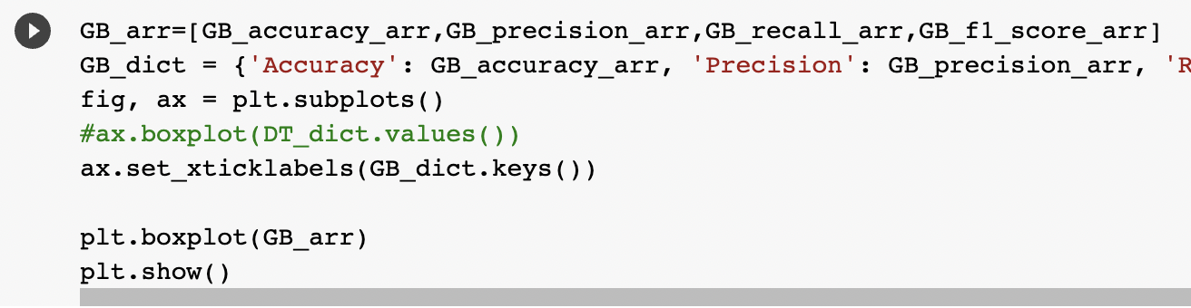

Also I used it here to create the radar for all models

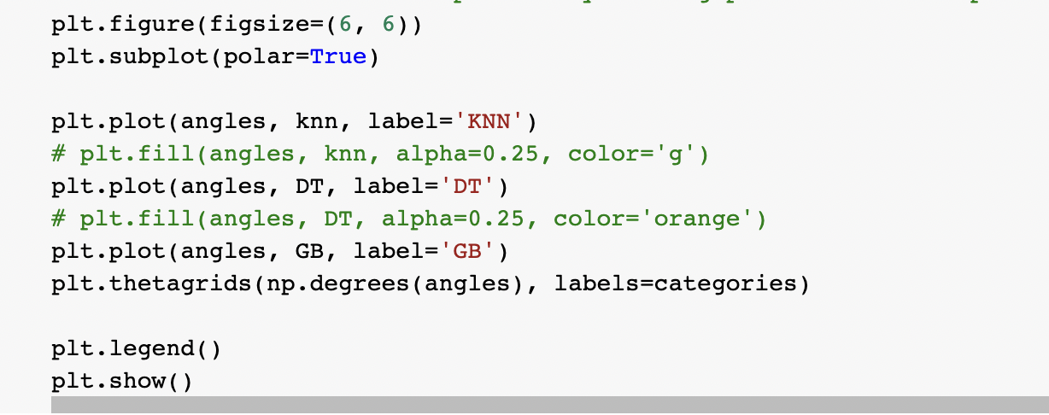

**Pygame:**

Using this library, you may create video games using a collection of PYTHON modules. Python multimedia apps may also be made using it. The SDL library serves as Pygame's foundation. (Yıldırım, 2022)

**Keras**

is an open-source neural network library built on Python that enables fast experimentation with deep neural networks. The popularity of deep learning makes Keras an excellent choice since, according to its developers, it is an API (Application Programming Interface) made for people, not computers. In comparison to TensorFlow or Theano, Keras has a better acceptance rate in the scientific and industrial communities. (interviewbit, 2022)

features:

Because of its modular structure, Keras is exceedingly expressive, versatile, and well-suited to cutting-edge research.

It functions perfectly on both the Central Processing Unit and Graphics Processing Unit (Graphics Processing Unit). (interviewbit, 2022)

**TensorFlow:**

is an open-source, high-performance numerical computation library. Additionally, it is used in machine learning and deep learning techniques. It was developed by researchers on the Google Brain team, who work for Google AI, and is now extensively used by math, physics, and machine learning researchers for challenging mathematical computations. In order to do quick linear algebra computations, TensorFlow uses methods like XLA (XLA or Accelerated Linear Algebra is a domain-specific compiler for linear algebra that can accelerate TensorFlow models with maybe no source code modifications). (interviewbit, 2022)

## Plotting and visualization libraries

### **Plotly:** this library provides an interactive plot and is simple enough for beginners to understand, is the most widely used data visualization package in Python. It is frequently used to manage scientific, statistical, financial, and geographic data.

**Features:**

An advanced visualization library that is interactive and open-source.

**This library provides:**

provides dendrograms, dimension chars, and contour plots.

provides 40 different chart and plot formats.

(knowledgehut, 2023)

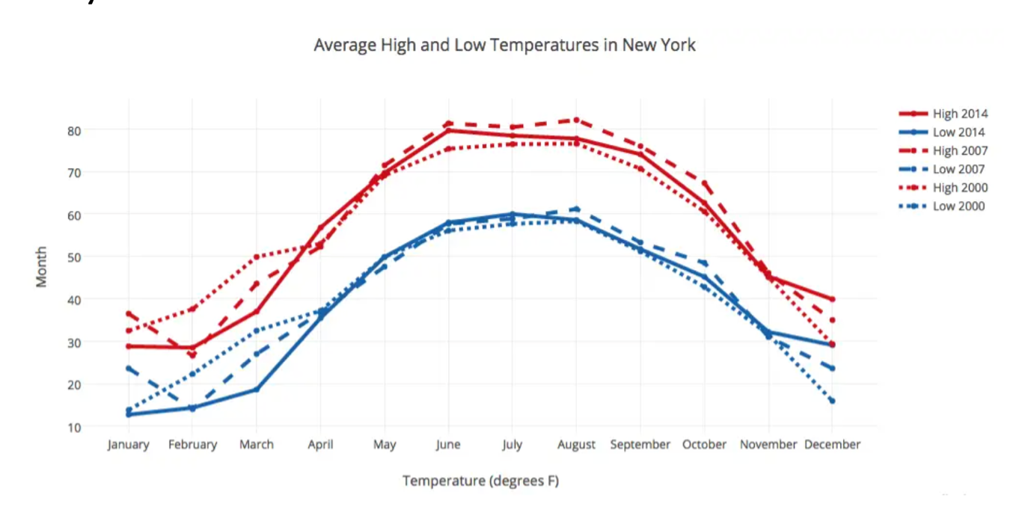

**Seaborn:** is the greatest data visualization package for Python, offering a wide range of visible patterns. It is frequently used for statistical visualization and was created to be more compatible with Pandas data structure. (knowledgehut, 2023)

**Features:**

It is incorporated to enable more thorough and in-depth data exploration and understanding.

It carries out the required mapping and aggregation to create information graphics.

(knowledgehut, 2023)

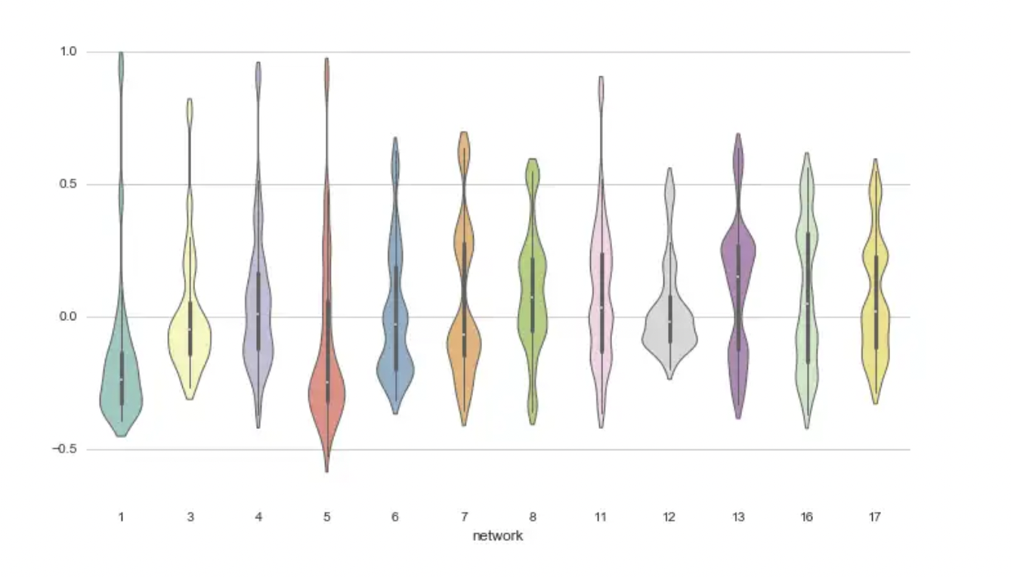

**GGPlot:** is another well-liked Python data visualization toolkit, also referred to as the graphics grammar implementation in Python. It alludes to the data map, which has aesthetic features like color, form, and geometric elements like points and bars. (knowledgehut, 2023)

**Features:**

It enables you to construct educational visualizations far more effectively with better representations.

To save data in a data frame, it is connected with Panda.

The documentation is clear and easy to understand.

(knowledgehut, 2023)

**Missingo:** Instead of scrolling through a table, missingno enables you to rapidly assess the completeness of a dataset with a visual summary. Data may be filtered and sorted according to completeness, and correlations can be found using heatmaps or dendrograms. (mode.com, 2023)

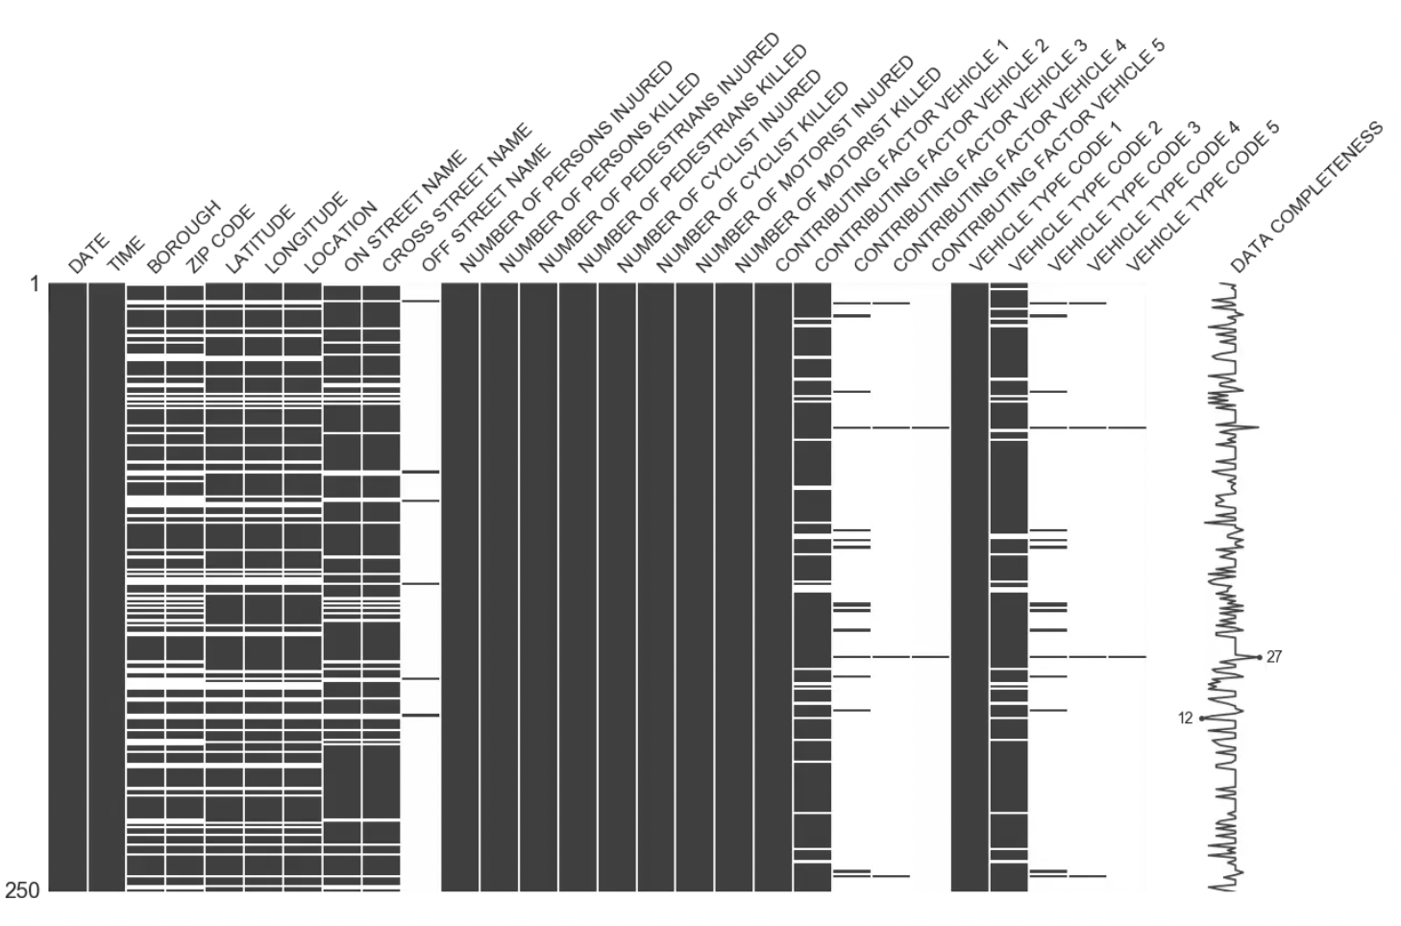

**Geoplotlib**: is a set of tools for drawing maps and displaying geographic information. It may be used to produce several kinds of maps, including choropleths, heatmaps, and dot density maps. (mode.com, 2023)

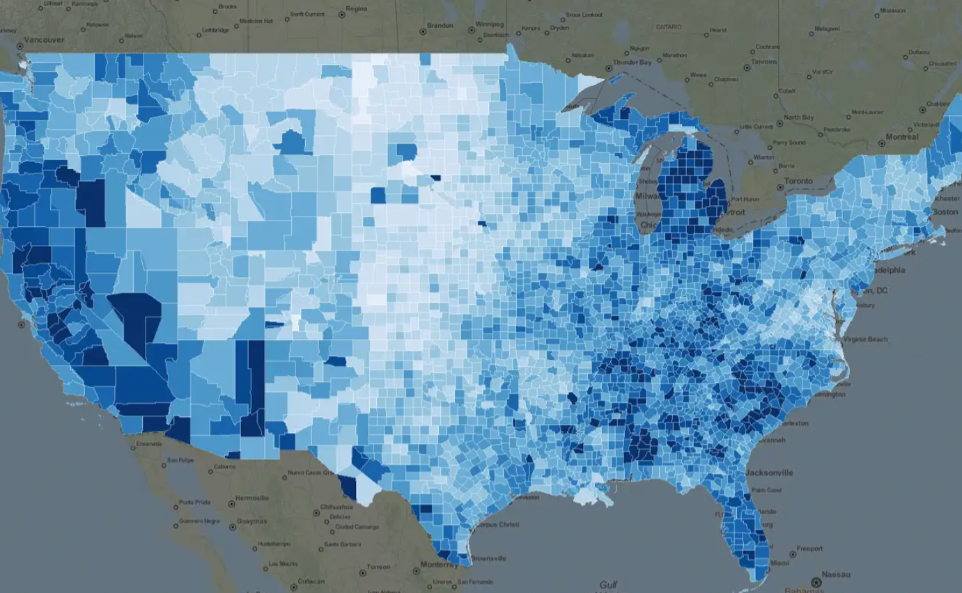

# Experiments

## Programming languages and tool

I have written a program using the Python language and had write the code on CoLab.

## Load Data and Prepare Data (Preprocessing)

At the first, I load the CSV file by this syntax (pd.read_filetype()), then used this syntax (data. isnull().sum()) to see how many nulls I have in each column.

After that, I started deleting all the columns that I saw that I don’t need and they will not help me with anything and they are not dependent on other columns or other columns are dependent on these columns such as: CASE_ID, OPEN_DATE, CLOSE_DATE, OPEN_USER, CLOSE_USER, RESOLUTION, RESOLUTION_DESCRIPTION, CASE_DESC.

After I deleted all the columns that I don’t want I started to fill the nulls values in the columns (OFFER_NAME, CUSTOMER_GROUP, ESCALATED_GROUP, OPEN_GR, CLOSE_GROUP, CALLBACK_MECHANISM, AGE_BRACKET).

|  |  |  |  |
| --- | --- | --- | --- |
| **Step** | **Column/step Name** | **Description** | **Justification** |
|  | CASE_ID | I deleted this column | I deleted the CASE_ID because I see it as waste data that is taking place in the storage, and it will not help me with anything |
|  | OPEN_DATE | I deleted this column | I deleted the OPEN_DATE and the CLOSE_DATE because for me I don’t care about the open date and the close date I just care about how many doses this problem takes time, I mean the period between the open date and the close date which I can found it in the AGE_BRACHET |
|  | CLOSE_DATE | I deleted this column |
| **…** | OPEN_USER | I deleted this column | I deleted the OPEN_USER and the CLOSE_USER because it is not important information for me to know who is the user who opens and closes the problem, and also the open user and the close contain big data and this data is just for one employee, but on the other hand, I have the OPEN_GROUP and the CLOSE_GROUP so these as more useful because the group contains more than one employee so I can see the name of the group that contains more than one. |
|  | CLOSE_USER | I deleted this column |
|  | RESOLUTION | I deleted this column | I deleted the RESOLUTION, RESOLUTION_DESCRIPTION, and CASE_DESC because they contain a lot of null values over 80%, and they are not dependent on anything, it will be so difficult to handle them. |
|  | RESOLUTION_DESCRIPTION | I deleted this column |
|  | CASE_DESC | I deleted this column |
|  | OFFER_NAME | I filled all the null values with the string UNKNOWN | because I can't predict what the name of the customer offer is and if I filled it wrong it might make a problem between the customers and the company. |
|  | CUSTOMER_GROUP | I filled all the null values with the mode which means, first I saw the count of every customer group before filling the nulls and then I fill all the nulls with the same value of the most repeated value. | Because from what I saw that most of the customers are from the FTTH Home group and because I did not find any coloration or relation between this column and other columns so this was the best way to fill the nulls in a realistic way |
|  | ESCALATED_GROUP | I fill all the null values with the string NOT_ESCALATED. | this column is dependent on the ESCALATED_FLAG so what I came up with is that when the problem is not escalated this means that there are no groups that did escalate the problem because from the beginning there were not escalated |
|  | CALLBACK_MECHANI | I filled 50% of the nulls with the string SMS and the other 50% of the nulls with the string Phone | I consider this way is the best because maybe not all the customers have an email but all the customers have a telephone that has a number card in it. |
|  | AGE_BRACKET | I filled all the null values with the string STILL_ACTIVE | because as we can see every cell that is null is also the same cell in the close date is null, and as I said before that the AGE_BRACHET is the period between the OPEN_DATE and the CLOSE_DATE so we can consider that the cell in the AGE_BRACKET that have a null value it does not have a CLOSE_DATE which means it is still ACTIVE |
|  | OPEN_GR | I put a code which will help mee to fill the nulls, first the code checks the probability of each value, and then this part of code will convert each probability to a percentage value, then the nulls values will be filled randomly based on the percentage | Because I don’t want fill the nulls with the mode because I don’t want all the nulls to be filled with the same value because it is not logical like this and I want the nulls to be filled with the three values (small, medium, large ) but each value has different count based on its probability |
|  | CLOSE_GROUP | Because I don’t want fill the nulls with the mode because I don’t want all the nulls to be filled with the same value because it is not logical like this and I want the nulls to be filled with the three values (small, medium, large ) but each value has different count based on its probability |

## Approaches

|  |  |  |
| --- | --- | --- |
| **Approach no.** | **Name** | **Description** |
|  | kNN | A method known as "k-nearest neighbor" predicts a data point's probability of belonging to one group or the other based on which group the data points closest to it belong to.(techopedia, 2023) |
|  | The Decision Tree model | is a tree structure that simulates a flowchart where each leaf node symbolizes the result, the branch represents a decision rule, and the inside nodes indicate features (or attributes). It is a flowchart-like visualization that perfectly simulates how people think. Decision trees are simple to recognize and interpret because of this. (Navlani, 2018)  **How its work:**  Using Attribute Selection Measures (ASM) to divide the records, choose the best attribute.  Divide the dataset into smaller sections and make that attribute a decision node.  Recursively repeat this step for each node kid to begin growing the tree (Navlani, 2018) |
|  | The Gaussian Naive Bayes model | Naive Bayes classification is a simple and effective algorithm for the classification job in machine learning. The foundation of naive Bayes classification is the use of the Bayes theorem with a strong assumption of feature independence. When we use naive Bayes classification to textual data analysis tasks like natural language processing, we get good outcomes. (prashant111, 2020) |

# Results

## Compare the different models

|  |  |  |  |  |
| --- | --- | --- | --- | --- |
| **Approach no.** | **Accuracy** | **Precision** | **Recall** | **F1-Score** |
|  | 0.9395103216514643 | 0.8909465020576132 | 0.8557312252964426 | 0.8557312252964426 |
|  | 0.9927988478156505 | 0.9842209072978305 | 0.9861660079051383 | 0.9861660079051383 |
|  | 0.8194911185789726 | 0.6490825688073396 | 0.5592885375494071 | 0.6008492569002123 |
| **…** |  |  |  |  |

As we can see here the results of the Accuracy, Precision, Recall, and F1-Score of the three machine learning models, (1) show the results of the KNN model, (2)shows the results of the DT model, (3)shows the results of the GB model

## Charts

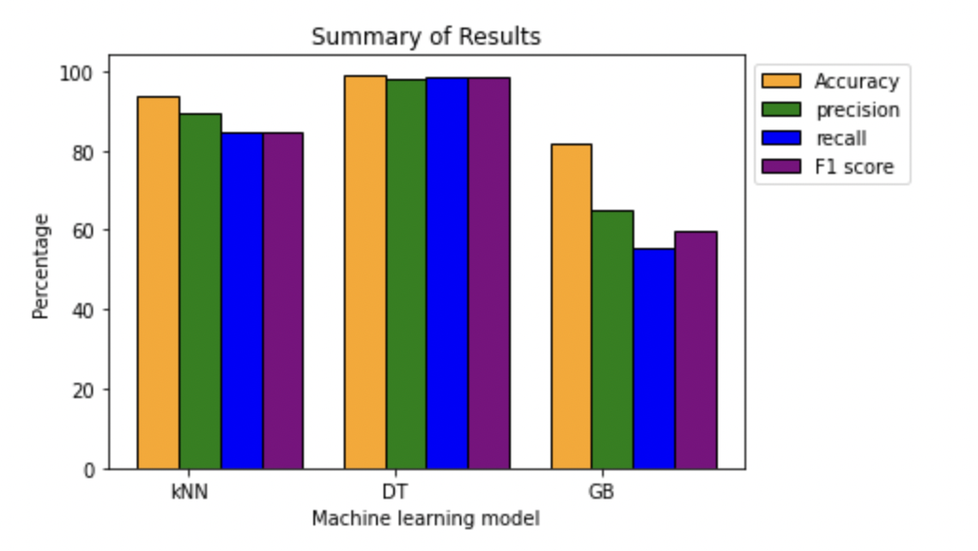

This chart is called a bar chart from the matplotlib library, this chart shows the results of the four measures for the three models (KNN, DT, GB), as we can see in the legend the orange represents the Accuracy and the green represent the precision and the blue represents the Recall and the purple represent the F1_score.

The length of the bar represents the value of each measure

As we can see here that the DT model has achieved the highest values of the measures which means it is the best model according to the chart

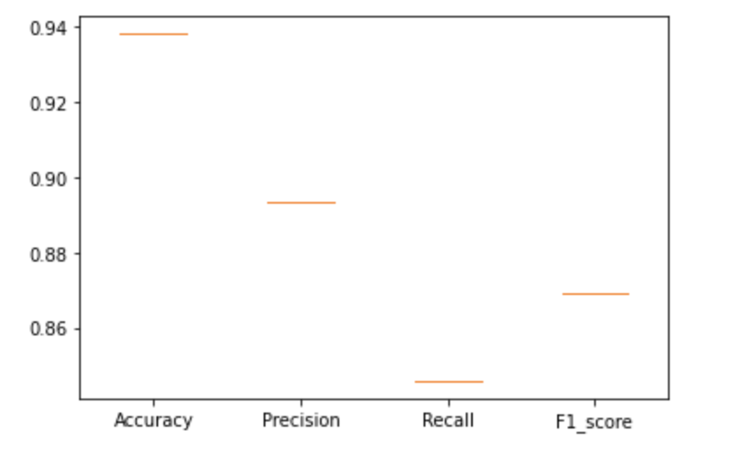

This chart Is called a boxplot, and it was also imported from the matplotlib library, this chart shows the results of the four measures but this chart can contain just one model which means we will have three boxplots for the three models.

This chart shows the KNN model, also we can see that the values are lines instead of boxes which means that all the values of each measure that came from the 10 times loop are so close or have the same values so that's why it appeared as a line, not a box also this model algorithm gives the same results every time you run it

The orange line shows the median

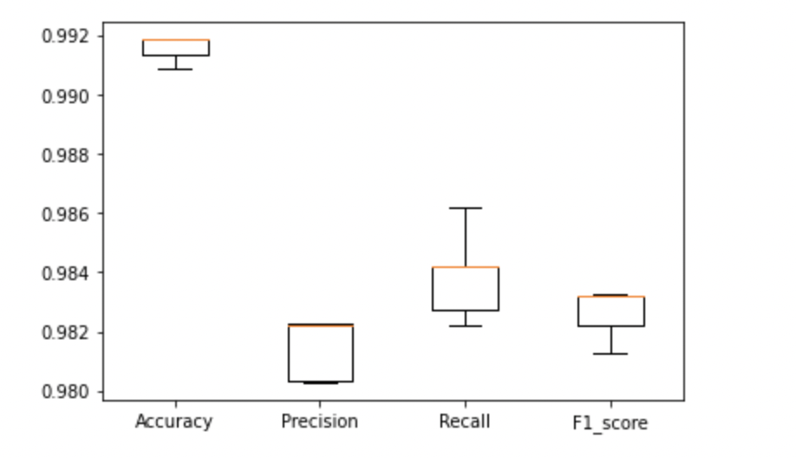

This chart shows the DT model, but in this model, the values of each measure appeared as a box which means that the 10 times loop results of each measure were far apart and unequal (There is a gap between the results) and because this model algorithm do not give the same results every time you run it

The orange line shows the median and The box shows where the results are concentrated

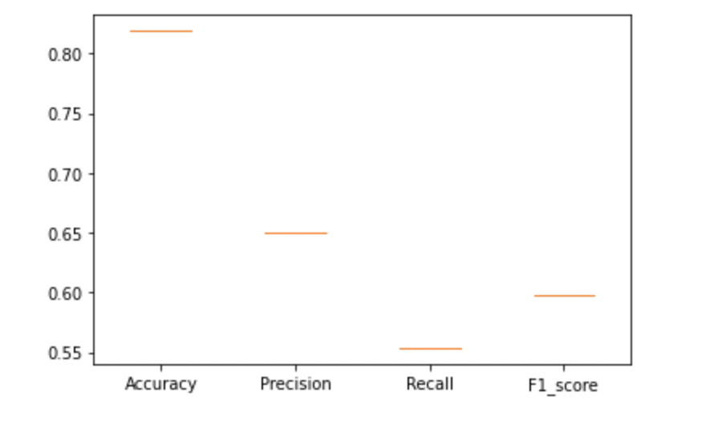

This chart shows the GB model, also we can see that the values are lines instead of boxes which means that all the values of each measure that came from the 10 times loop are so close or have the same values so that's why it appeared as a line, not a box also this model algorithm gives the same results every time you run it

The orange line shows the median.

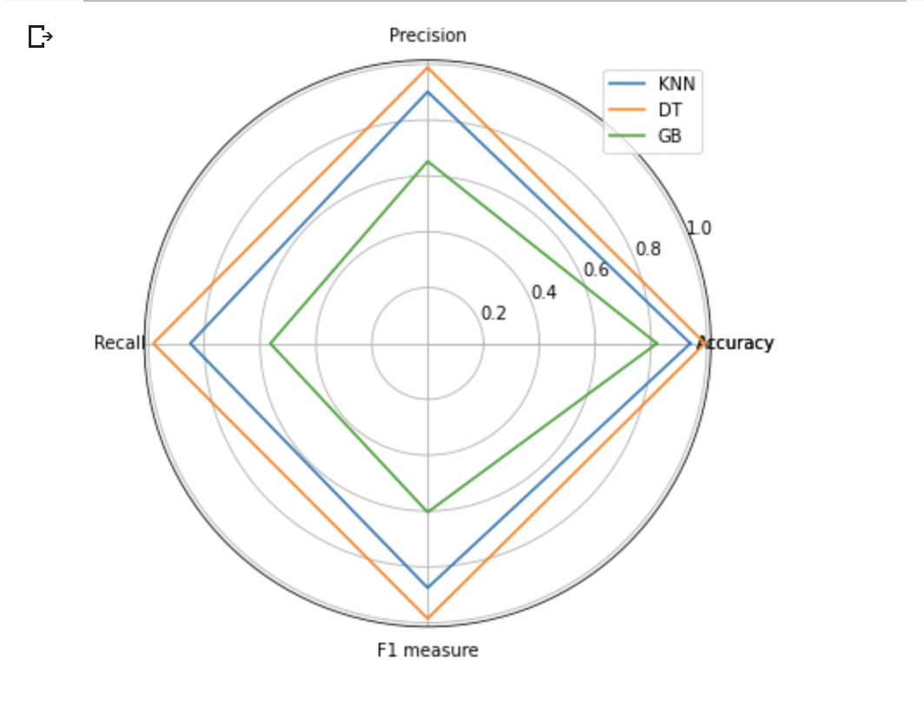

This chart is called a radar chart from the matplotlib library, this chart shows the results of the four measures for the three models (KNN, DT, GB), as we can see in the legend the orange represents the DT and the green represents GB and the blue represents KNN.

## Analysis of the results

As u can see in my code I used three models which are: The kNN model, The Decision Tree model, and The Gaussian Naive Bayes model and I have applied four measures which were

Accuracy, Precision, Recall, and F1_score I used them so I can see and evaluate how good my program is. As we can see in the program code on the CoLab the Decision Tree model gives me the highest values, which is very good, and this means that the Decision Tree model is the best model among the used models.

Confirming on what I got I made a data visualization: the first one is a bar chart, Based on the bar chart also I found that the DT got the highest values of Accuracy, Precision, Recall, and F1_score(the DT got the longest bars out there) all the values of the measures were over 0.89.

The values of the KNN model were in the middle and the values of the measures were between 0.85 and 0.93. But the values of the GB model were too low the values of the measures were between 0.55 and 0.81

The second one was the Boxplot and also the DT boxplot shows the highest values, if we focus on the scale of the DT boxplot it was between 0.890 and 0.992 but the scale of the KNN boxplot was between 0.86 and 0.94 and the scale of the GB boxplot was between 0.88 and 0.80

So also we can see from the boxplots that the DT gives the highest values

Coming to the last of the charts, which was the radar chart as we can see that the orange lines are almost touching the edges of the circle, unlike the blue lines and the green lines, almost touching the circle edges mean the values are getting closer to 100% which is what we need

In a conclusion, after I have applied the three models and results were that the DT is the best model because It haves mee the best results, but I did not stop there I have to double-check this so applied a data visualization, they were 5 charts, one bar chart for all the models and three boxplots for the three models and one radar chart for the three models and the results was the same that the DT model gives the highest values which now I can say that the DT is the best model to work on

# Evaluation

## The choice of data structures

**DataFrame:**

First, I used the DataFrame because it is usually used in machine learning and as I heard DataFrame makes it possible to deal with big data and analyse it also easy to handle data that are in the DataFrame, and DataFrames are so flexible.

And, because the DataFrames allow me to arrange the data in a table like excel which means DataFrames contains columns and rows

And on the other hand, DataFrames are so easy to use, more powerful than excel sheets, and faster.

Also I can check the number of rows and columns in a DataFrame using the "shape" property and i can use the "head()" and "tail()" methods to see the first and last few rows of the DataFrame, respectively and i can sort the DataFrame based on one or more columns using the "sort_values()" method and You can group the DataFrame by one or more columns and perform operations such as counting, summing, and aggregating using the "groupby()" method.

So it is so help full

.

**Series:**

I used the series every time I access a column in the DataFrame because the DataFrame is a collection of series.



As we can see every time I access a column in the data frame I used the series because this column is a series which means accessing a column accessing a series

Is data structure so helps full because:

I can access an individual element of the series by using its index or label.

I can extract a portion of the series by slicing it with the start and end indices.

I can perform mathematical operations on the series, such as addition, subtraction, multiplication, and division.

I can filter the series based on certain conditions, such as finding all values greater than a certain value.

I can group the series based on certain criteria, such as grouping all values based on their values.

i can plot the series using various types of charts

I can perform aggregate operations on the series, such as mean, sum, min, max

**Arrays:**



Here is a small example in my code when I used an Array, as we can see I created four Arrays from 10 columns and I fill it with zeros

I created the array because I want to save all the values that are coming from the loop

I made these arrays in case I want to get the mean of something

It is one of the easiest methods that are used to store data and deal with it, and it facilitates work a lot instead of 20 lines only through which I took 4 lines and enables me to use it at any time later with the addition that it can be cut

## Selection of the appropriate libraries

**Pandas:**

It is so useful because It offers a number of tools and techniques to handle and work with dataframes, or data in the form of tables. Data cleansing, transformation, aggregation, and analysis are just a few of the many features the library offers also The library offers a variety of features for processing and cleaning data, such as handling missing values, duplicate data, and data transformation.

Large dataset management and processing may be done quickly and effectively with the help of Pandas and Pandas has a wide range of built-in data analysis features, such as the ability to combine and aggregate data, produce statistics and visualizations, and deal with time series data and Pandas is simple to use in conjunction with other tools because of how well it interfaces with other well-known data science libraries like NumPy and Matplotlib.

**I used the panda library to:**

**1-To Load Data:**

so I can load the CSV file and open it to read, just by writing this syntax (pd.read_filetype()).

**2-To Make DataFrames**

**3-To Clean Data:**

By using some syntaxes such as:

pd. isnull().sum: to see how many null values I have in the data set.

df. dropna: to delete any row that contains a null value.

**4-To Fill Data:**

By using this syntax

Df. fillna(“string or int or ….”): to replace the null values with another value.

**5-To Visualize Data**

**6-To View The Data:**

By using some syntaxes such as:

df. head(): to print the data.

df. shape(): to see how many columns and rows this data is.

**7- statistics:**

By using some syntaxes such as:

df. mean(): to return the mean of all the columns.

df. Max: to return the highest value in each column.

df. Min: to return the lowest value in each column.

df. median: to return the median of each column.

NumPy:

This library helped me so much even in the handling It made my job a lot easier

For massive data processing and scientific computing, NumPy's operations and functions, like array computations and manipulation, must be quick and effective also For smooth integration and usage in a variety of data analysis and machine learning applications, NumPy's interoperability with other data science libraries, including as Pandas, Scikit-learn, Matplotlib, and TensorFlow, is essential also For managing big datasets, preventing data loss, and assuring correct results, NumPy's functions, operations, and algorithms must be stable, reliable, and capable of handling errors.

I used the NumPy library

To make a random choice.

By this function

np. random. choice():





As we can see here a little example of how I did use the NumPy library in my code to use a random generator

**Sklearn:**

It is a very helpful library It offers a variety of algorithms for classification, regression, clustering, and dimensionality reduction and also scikit-learn is designed for performance, and it can scale to handle large datasets efficiently which helps me on working on this data set and also It works well with other scientific Python libraries like NumPy and Pandas, making it simpler for users to complete difficult data analysis and modeling jobs also making it easy to switch between algorithms and compare results

Sklearn also offers many built-in evaluation metrics, including accuracy, precision, recall, and F1 score This makes it simple for me to assess the performance of my models and pick the best model for their needs also In order to do evaluation, the data is often divided into training and testing sets. The model is then trained on the training data and evaluated on the testing data. This makes it more likely that the model will generalize well to new data and that it has not been overfit to the training set of data.

Here are some examples of how I used this library in my code and in what it helps me

1. I used it to split the data set into a train and test



1. I used it to import the KNN learning model



1. I used it to import the DT learning model



1. I used it to import the GB learning model



**Matplotlib:**

This library it offers a wide range of customisable capabilities for creating different graphs and charts which helps me a lot in my project Working with real-world datasets is made simple by the ease with which Matplotlib interfaces with other well-liked Python libraries like NumPy, pandas, and scikit-learn and also It may be applied to a broad variety of data visualization applications, such as data exploration, results sharing, and the depiction of numerical or scientific data A high-level interface is provided by Matplotlib for creating appealing and educational statistics visualizations that I used in my project the main thing that it offers a high-level interface for generating just a few lines of code to create charts.

I can modify Matplotlib's plots using a wide range of features, including color, size, labels, and markers.

Here are some examples of how I used this library in my code:

I have used it in visualization

First I imported the library



As we can see I used it to create the bar plot



I used it here to create the boxplot for the KNN model



I used it here to create the boxplot for the DT model



I used it to create the boxplot for the GB model



Also I used it here to create the radar for all models



## The effectiveness of different models

I have used three different models, the first one was the KNN model, the second one was DT model, and the GB model, after I applied them to my program I checked and then I checked the results of four measures, in the first time all the values of the measures for the three models were under 0.70 so I consider that there are some issues in the pre-processing (handling the nulls) so I went back to the handling part and I have changed some of the filling technics and then I applied the models again to see the results and the results were satisfactory. So the models had the main role in evaluating the pre-processing and in taking the decision if we adopt or make changes to the handling after that did a comparison between the results of the four models to judge which model I will adopt based on the highest results

As a result, the effectiveness of the Dt model was so high and the results of the four measures were between 0.89 and 0.99 which means the predicted values was matching the real values in the range between 0.89 and 0.99 so this model was chosen instead of the KNN and GB models.

By the way, the effectiveness of the KNN model was not good as the DT and was not bad as the GB the results of the 4 measures were between 0.85 and 0.93 based on the results you can see it is less effective than the DT, but the GB was the lest effectiveness between the DT and KNN models which we can see from the results that we got them from the four measures ware between 0.88 and 0.80

## Recommendations

I recommend the organization to use the pandas and NumPy libraries if they want to work on big Data sets because these libraries offer a lot of helps that saves time and effort while handling the nulls.

Also, I recommend the organization to use the DT learning model on the COMPLAINT_TYPE column because it will give the best result

Also, I recommend the organization to make a testing period every time they change anything in the pre-processing part and double-check the result by applying the 3 models and the 4 measures

Also, I recommend the organization to use the Scikit-learn library to apply the learning models because it contain a lot of models types and so easy to work with them

Also, I recommend the organization to use the Matplotlib library for visualization because it contains a lot of chart types and it is easy to deal with it and you can easily understand and analyse what you see in the chart

Introduction

Types of data structures

edureka (2022) *Data Structures in python: List, tuple, dict, sets, stack, queue*, *Edureka*. Available at: https://www.edureka.co/blog/data-structures-in-python/#arrayvslist (Accessed: January 18, 2023).

w3schools, w3schools (2023) Python tuples. Available at: https://www.w3schools.com/python/python_tuples.asp (Accessed: January 18, 2023).

geeksforgeeks (2023) *Graph data structure and algorithms*, *GeeksforGeeks*. GeeksforGeeks. Available at: https://www.geeksforgeeks.org/graph-data-structure-and-algorithms/ (Accessed: January 18, 2023).

Raj, A. (2021) *Tree data structure in Python*, *PythonForBeginners.com*. Available at: https://www.pythonforbeginners.com/data-structures/tree-data-structure-in-python#:~:text=Conclusion-,What%20is%20a%20Tree%20Data%20Structure%20in%20Python%3F,each%20element%20of%20the%20tree. (Accessed: January 18, 2023).

programiz (2023) *Stack Data Structure*, *Programiz*. Available at: https://www.programiz.com/dsa/stack (Accessed: January 18, 2023).

## Common libraries

Team, G.L. (2022) *Python numpy tutorial - 2023*, *Great Learning Blog: Free Resources what Matters to shape your Career!* Available at: https://www.mygreatlearning.com/blog/python-numpy-tutorial/#what-is-numpy-in-python (Accessed: January 19, 2023).

Yıldırım, S. (2022) *The most popular python libraries*, *LearnPython.com*. LearnPython.com. Available at: https://learnpython.com/blog/popular-python-libraries/ (Accessed: January 19, 2023).

interviewbit (2022) *Top 10 python libraries*, *InterviewBit*. Available at: https://www.interviewbit.com/blog/python-libraries/ (Accessed: January 19, 2023).

interviewbit (2022) *Top 10 python libraries*, *InterviewBit*. Available at: https://www.interviewbit.com/blog/python-libraries/ (Accessed: January 19, 2023).

## Plotting and visualization libraries

knowledgehut (2023) *Top 10 python libraries for Data Visualization*, *KnowledgeHut*. Available at: https://www.knowledgehut.com/blog/business-intelligence-and-visualization/python-data-visualization-libraries (Accessed: January 19, 2023).

mode.com (2023) *12 python data visualization libraries to explore for business analysis*, *Mode*. Available at: https://mode.com/blog/python-data-visualization-libraries/ (Accessed: January 19, 2023).

# Experiments

## Approaches

techopedia (2023) *What is K-nearest neighbor (K-NN)? - definition from Techopedia*, *Techopedia.com*. Available at: https://www.techopedia.com/definition/32066/k-nearest-neighbor-k-nn (Accessed: January 19, 2023).

Navlani, A. (2018) *Python decision tree classification tutorial: Scikit-Learn Decisiontreeclassifier*, *DataCamp*. DataCamp. Available at: https://www.datacamp.com/tutorial/decision-tree-classification-python (Accessed: January 19, 2023).

prashant111 (2020) *Naive Bayes classifier in Python*, *Kaggle*. Kaggle. Available at: https://www.kaggle.com/code/prashant111/naive-bayes-classifier-in-python (Accessed: January 19, 2023).